**ST. MARCELINO ACADEMY-MATUGGA**

**END OF AUGUST HOME STUDY ASSESSMENT**

**SUBJECT: LITERACY A (SCIENCE)**

**CLASS: PRIMARY ONE**

**NAME: …………………………………………………..……... STREAM: …………**

1. **Fill in the missing letter to form meaningful words.**

c __ __ k

cl__aner

t__ilet

n__rse

1. **Circle 4 things we use at school**

cow book chair goat bed pencil water

1. **Match people to their work.**

nurse cooking food

teacher cleaning our school

cleaner caring for sick pupils

cook teaching children

1. **Draw these personal properties**

|  |  |  |  |
| --- | --- | --- | --- |
|  |  |  |  |
| **bag** | **toothbrush** | **sponge** | **towel** |

1. **Name these dangerous objects**
2.  __________________________________
3. 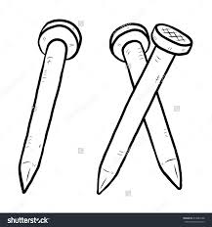 __________________________________

c) 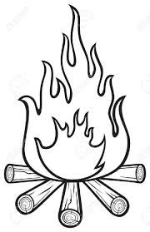 __________________________________

d)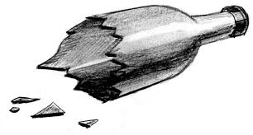 __________________________________

**(fire, razorblade, nails, broken bottle)**

1. **Draw these buildings found at school.**

|  |  |
| --- | --- |
|  |  |
| kitchen | toilet |

1. **Read and match correctly.**

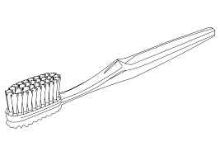

brushing teeth

combing hair

mopping

sweeping



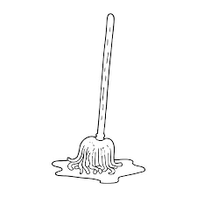

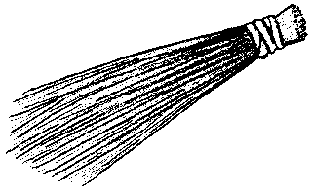

1. **Name these body parts.**

|  |  |  |  |
| --- | --- | --- | --- |
|  |  |  |  |
|  |  |  |  |

1. **Tick four things we use to clean our school.**

water, bed, mop, broom, teacher, rag, water

1. **Match correctly**

nurse office

cleaner kitchen

cook sickbay

head teacher toilet/compound

1. **Name these things we use to clean our bodies**

|  |  |  |  |
| --- | --- | --- | --- |
|  |  |  |  |
|  |  |  |  |

**(toothbrush, sponge, soap, comb)**

1. **Name the school property below.**

______________________________________________________

How is it useful at our school? ______________________________________________________

1. **Underline four ways of keeping our school clean.**

by sweeping, by sleeping, by washing utensils, by crying,

by mopping, by picking rubbish, by running

1. **Name these school properties.**

a) _____________________________________

b)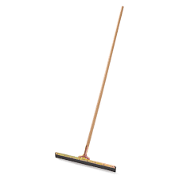_____________________________________

**(broom, squeegee, mop)**

|  |  |
| --- | --- |
| **Parent’s comment:** | **…………………………………………………………** |
| **Signature:** | **…………………………………………………………** |
| **Contact:** |  |

**END**